Week 4: Deployment on Flask

Name: Aman Niyaz
Batch Code: LISP01
Submission Date: 22 March 2021
Submitted to: Data Glacier

Step 1: Writing Flask Application
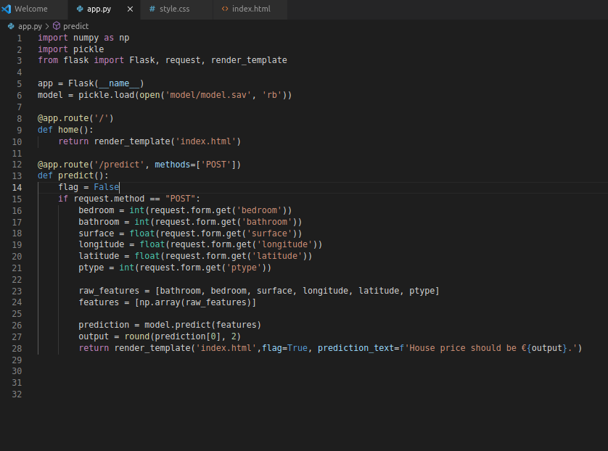

Step 2: Running the Flask Application
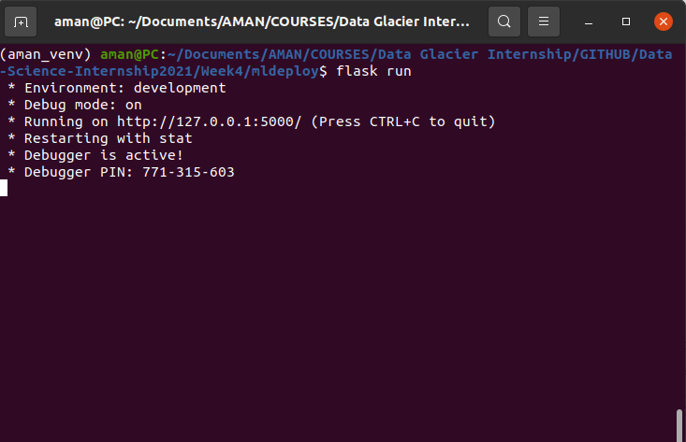
Step 3: Open the link in the browser
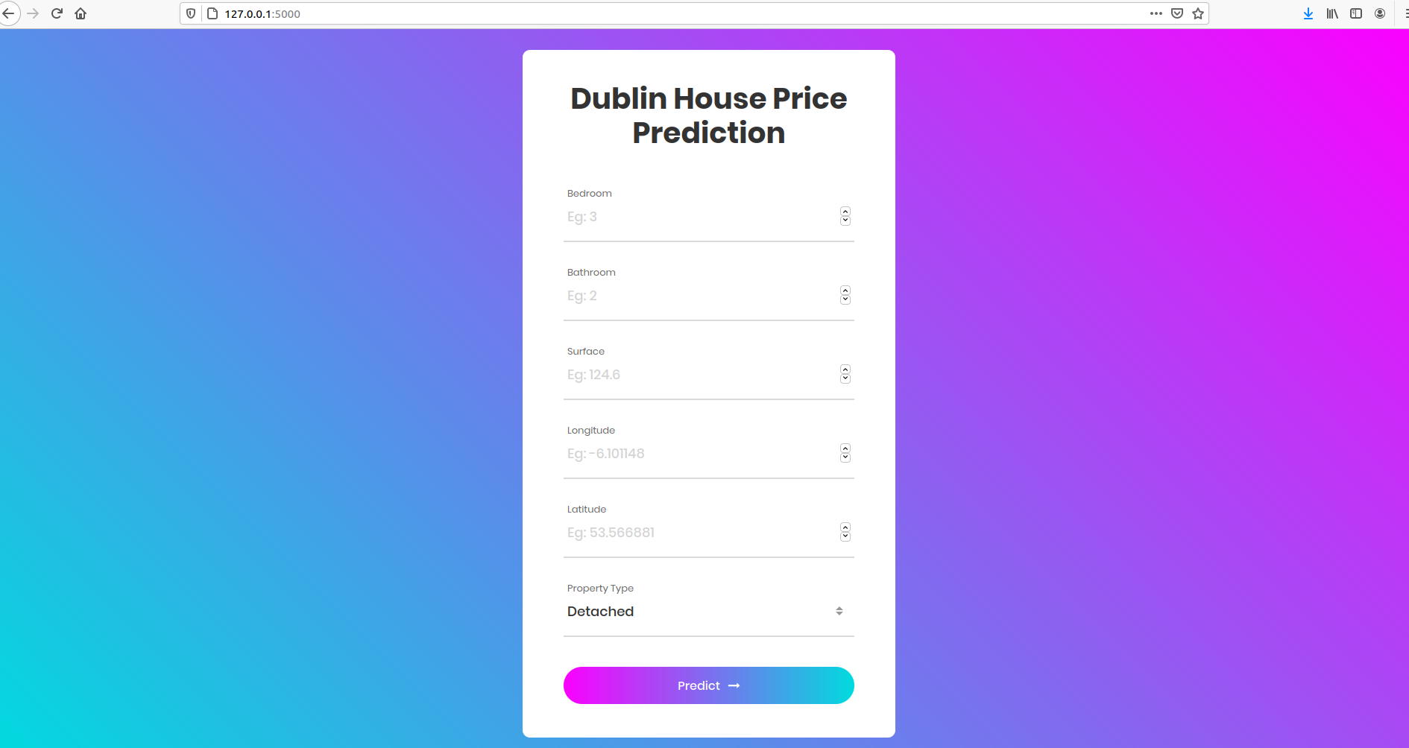

Step 4: Testing the model
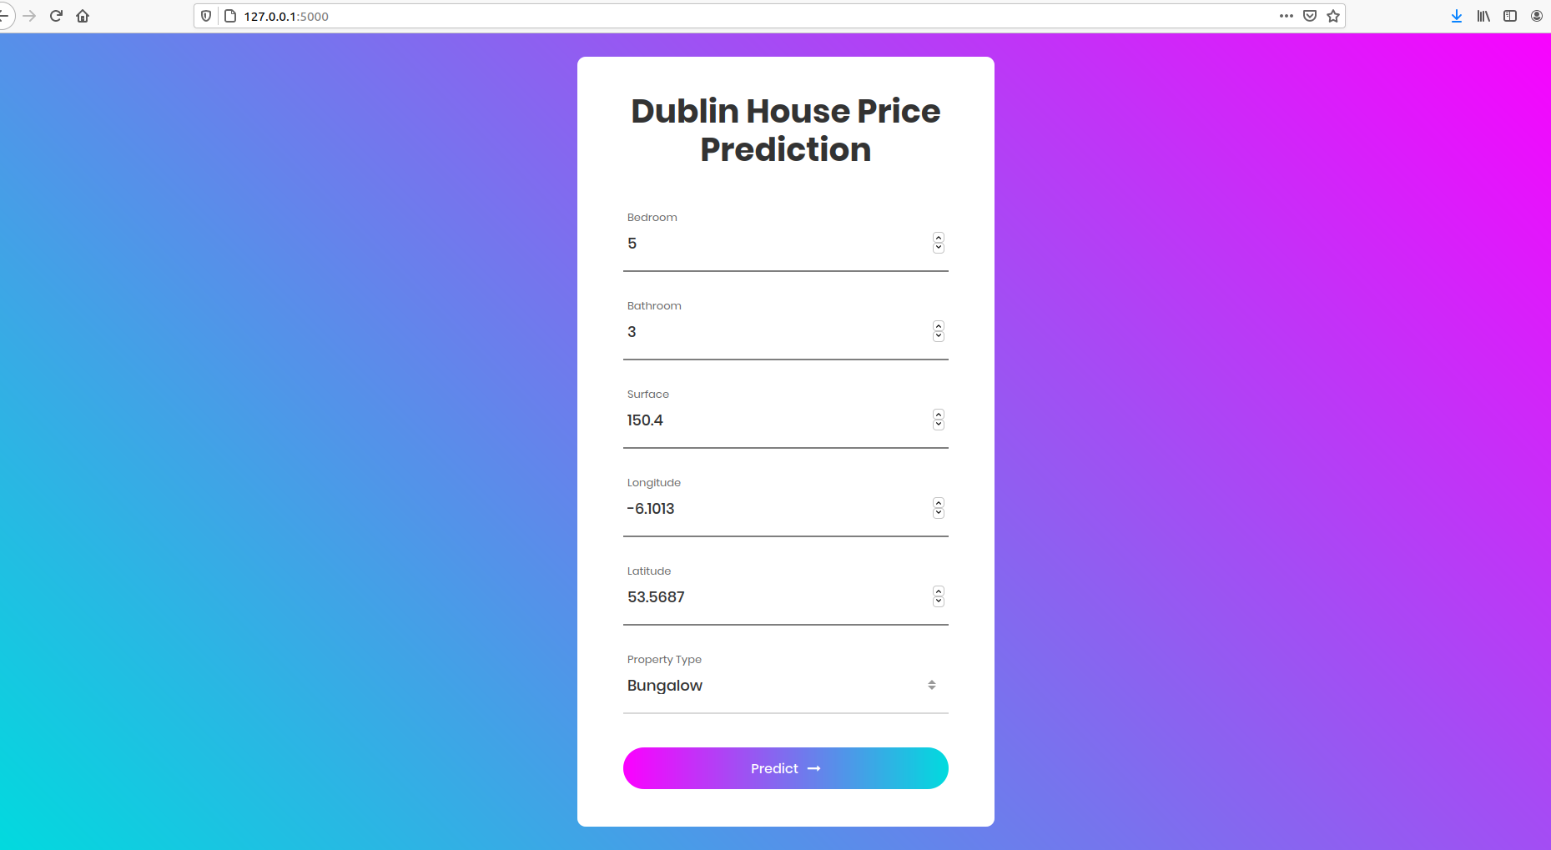
Step 5: Getting the result
